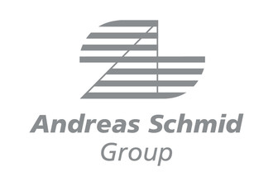
Export Authorization / Power of Attorney
  - For Customs Declaration in Direct Representation

Company : ________________________________________
Street : ________________________________________
Postal Code / Location : ________________________________________
Country : ________________________________________
EORI-Nr. : ________________________________________
VAT-ID / Tax-ID Nr. : ________________________________________
Contact Person / Phone-Nr : ________________________________________

We hereby authorize and commission the company Andreas Schmid Internationale Spedition GmbH & Co. KG (from now on referred to as “authorized party”) to handle customs clearance for our outbound export shipments in our name and in accordance with our instructions as our direct representative until the written revocation of this authorization.
This authorization entails the creation of export declarations on our behalf, signing the created export declarations, and every other necessary action related to customs clearance.
We furthermore recognize that the ADSp (Allgemeine Deutsche Spediteurbedingungen – ADSp 2017) shall apply to all shipments handled by the authorized party.

The signer confirms:

- We are the exporter / seller of the goods to be declared. (*)
- The origin of the goods is, unless otherwise stated, a country inside the EU. (*)
- We are an approved exporter. (*)
Our authorization number is: ___________________________.
- We are an authorized exporter. (*)
Our authorization number is: ___________________________.
- The goods to be declared do not fall under the category of Dual Use and do not require an export permit unless otherwise stated. In the latter case we will duly provide the authorized party with all necessary permits.
- All obligations related to foreign trade legislation fall under our responsibility. We confirm our compliance with any existing or future embargo, trade ban, trade restriction and export regulation. We assume full liability for the compliance with the aforementioned embargoes, bans, restrictions and regulations.
- We assume full liability towards the authorized party for the completeness and correctness of all information and documentation provided by us to the authorized party required for customs clearance.
- The authorized party is authorized to create further sub-authorizations.
- We are entitled to input tax deduction. (*)

Location, Date | Stamp & Signature

(*): Cross out if non-applicable.

